Using Cisco packet tracer,  
  
Connection in the network is passed like this   
PC-1 → FastEthernet 0 **to** Switch-1 → FastEthernet 1/0/1

Switch-1 → FastEthernet 1/0/2 **to** Switch-2 → FastEthernet 1/0/1

Switch-2 → FastEthernet 1/0/2 **to** PC-2 → FastEthernet 0

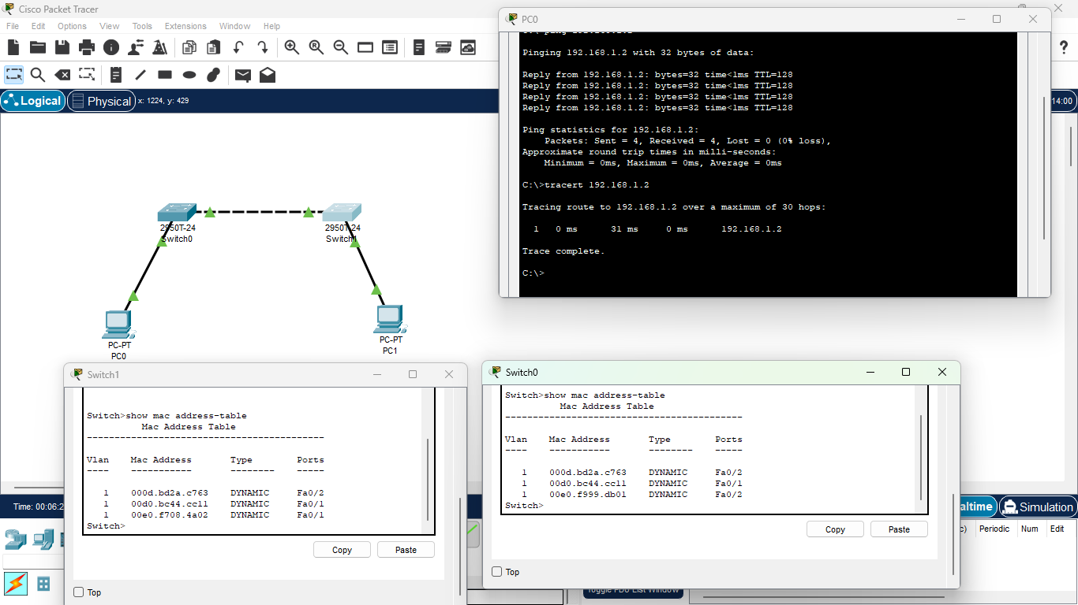  
  
Picture shows the CLI of both switches mentioning the MAC address when ping passed to verify packets checked through PC0 to PC1 and Traceroute of how many hops it took to reach the destination device